PRESS RELEASE
FOR IMMEDIATE RELEASE

Tolerance in the Eid al-Fitr Celebration in Singapore

Kuala Lumpur, Kominfo Newsroom – Singapore, the smallest country in Southeast Asia, shares the same value of diversity and tolerance as Indonesia. This includes the celebration of Eid al-Fitr.

The Indonesian Ambassador to Singapore, Suryo Pratomo, explained that Eid al-Fitr is celebrated by the Malay Muslim community in Singapore similar to the celebration in Indonesia.

“They hold open houses by inviting relatives and friends,” said Tommy, Suryo’s nickname, when he was contacted on Thursday (20 April 2023).
Tommy shared his experience with religious tolerance in Singapore during the Eid celebration and open house event when he was invited by the Second Minister for Education & Foreign Affairs of Singapore, Maliki Osman.
“The open house atmosphere was exactly like in Indonesia. Extraordinarily, his non-Muslim neighbor allowed Minister Osman to use their yard to accommodate guests for the gathering because Minister Osman’s private residence was not enough for a large number of attendees,” he said.

Moreover, the locals allowed the road in front of the minister’s house to be covered with tents as shades for the guests when they got out of their cars.

“Just like when there is a celebration in a housing complex or village in Indonesia,” said Tommy.

For the dishes, Singaporean Muslims also eat traditional Eid al-Fitr food like in Indonesia, such as satay, lontong (Indonesian rice cake), and pumpkin soup.

According to local government data, the Muslim population in Singapore accounts for 15.6% of the total population of 5.64 million people in 2022.

The majority of Muslims in Singapore are of ethnic Malay origin, while 13% of them are from the Indian Muslim community. The Singaporean government allowed the celebration of Eid al-Fitr this year, the first time after the COVID-19 pandemic.

“In Geylang, which is an area with a Malay Muslim community, the atmosphere is similar to Eid al-Fitr in Indonesia. The streets are decorated with lights, adding to the festive atmosphere of Eid al-Fitr,” said Ambassador Tommy.

The Indonesian Embassy in Singapore will also hold an open house for Eid al-Fitr this year. However, it will be limited to around 3,000 guests who are required to register online.

Tommy estimates that some Indonesian migrant workers in Singapore may opt to celebrate Eid al-Fitr in the country since it does not coincide with school holidays.

Based on data from the Indonesian Embassy, there are around 250,000 Indonesian nationals living in Singapore, or nearly 5% of the total population of Singapore. (Yashinta/Elvira/TR)
***

For more information, please contact:
Director General of Public Information and Communications of the Ministry of Communications and Informatics – Usman Kansong (0816785320).
Get other information at https://infopublik.id

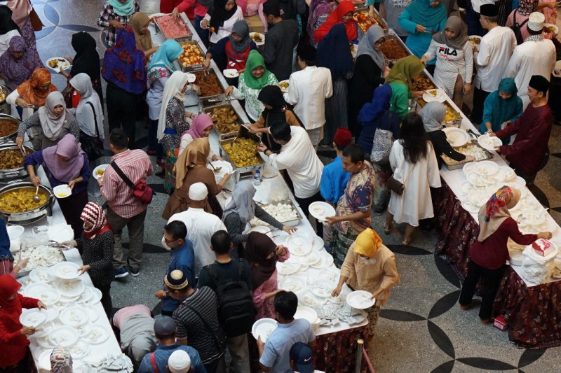

The atmosphere of Eid al-Fitr at the Indonesian Embassy in Singapore, Wednesday (5 June 2019). (Embassy of the Republic of Indonesia in Singapore)

